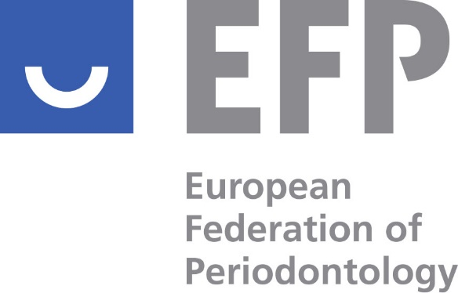

PROXY FORM
Extraordinary EFP General Assembly
to be held online on 10th May 2022
at 12:00 CET

On behalf of the …………………………………………… Society of Periodontology, full member society of the European Society of Periodontology (EFP) and as designated EFP Voting Delegate of this society,
I hereby give proxy to Nicola West, Secretary General, and Monique Danser, Treasurer, to represent me at the Extraordinary EFP General Assembly that shall be held remotely 10th May 2022 with the following agenda:

1.- Approval to allow the EFP to donate 5000€ to the EFP donation campaign in collaboration with the WHO Foundation to help the Ukrainians
2.- Approval of Uruguayan Society of Periodontology of Periodontology as EFP International Associate member

3.- Approval to suspend the Russian Society of Periodontology until the next General Assembly in 2023 according to the 2016 EFP By-Laws; paragraph 7.

My voting instructions are as follows: (see next page)

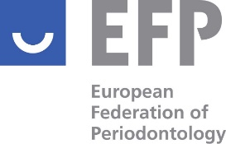

1.- Approval to allow the EFP to donate 5000€ to the EFP donation campaign in collaboration with the WHO Foundation to help the Ukrainians
□ Approve
□ Do not Approve

2.- Approval of Uruguayan Society of Periodontology of Periodontology as EFP International Associate member

□ Approve
□ Do not Approve

3.- Approval to suspend the Russian Society of Periodontology until the next General Assembly in 2023 according to the 2016 EFP By-Laws; paragraph 7
□ Approve
□ Do not Approve

EFP DELEGATE

Name:

Signature:

Date:

